When normal user i trying to install nginx service

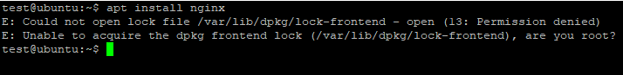

When we have added this user to sudo group

Asking passwd

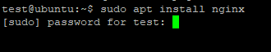

After entering passwd :

Started installing nginx service

